Our Mass Centres  Greenstead, St John Payne Catholic Church, CO4 3QD  Ardleigh St. Mary the Virgin (C of E), CO7 7LD  Mistley, St. Mary & St. Michael (C of E), CO11 1ER  Welcome  Please would you complete the Parish registration form so we can include you on Parish emails and make sure you are properly welcomed and that your needs are met. This is available on our website www.stjohnpayne.org.uk or at the back of the church after every Mass.  Contact Us  St. John Payne Catholic Parish Greenstead, Ardleigh & Mistley  21 Blackthorn Avenue, Colchester, CO4 3QD  Phone: 01206 870460  Email: greenstead@dioceseofbrentwood.org  Web: www.stjohnpayne.org.uk |  |  |  |  | St. John Payne Parish  Greenstead, Ardleigh & Mistley  We of St. John Payne Catholic Parish seek to reflect the joyful life affirming power of Christ’s Living Presence among all where Essex meets East Anglia  Welcome to our Parish  In Jesus Christ salvation is offered to all people,  as a gift of God’s grace and mercy  Who are we?  We are a small friendly Roman Catholic parish, growing in the love of God and in the love of each other. In our daily lives, we work to support and encourage each other as we learn to share the Good News of Jesus Christ. Everyone is welcome in our Parish no matter where they are on their journey through life.
Our aim  Our aim is to build a meaningful Christian community, a place where we are all known, loved, supported, where we each have a strong sense of belonging and where there is a real sense of joy as part of God’s family in all that we do.  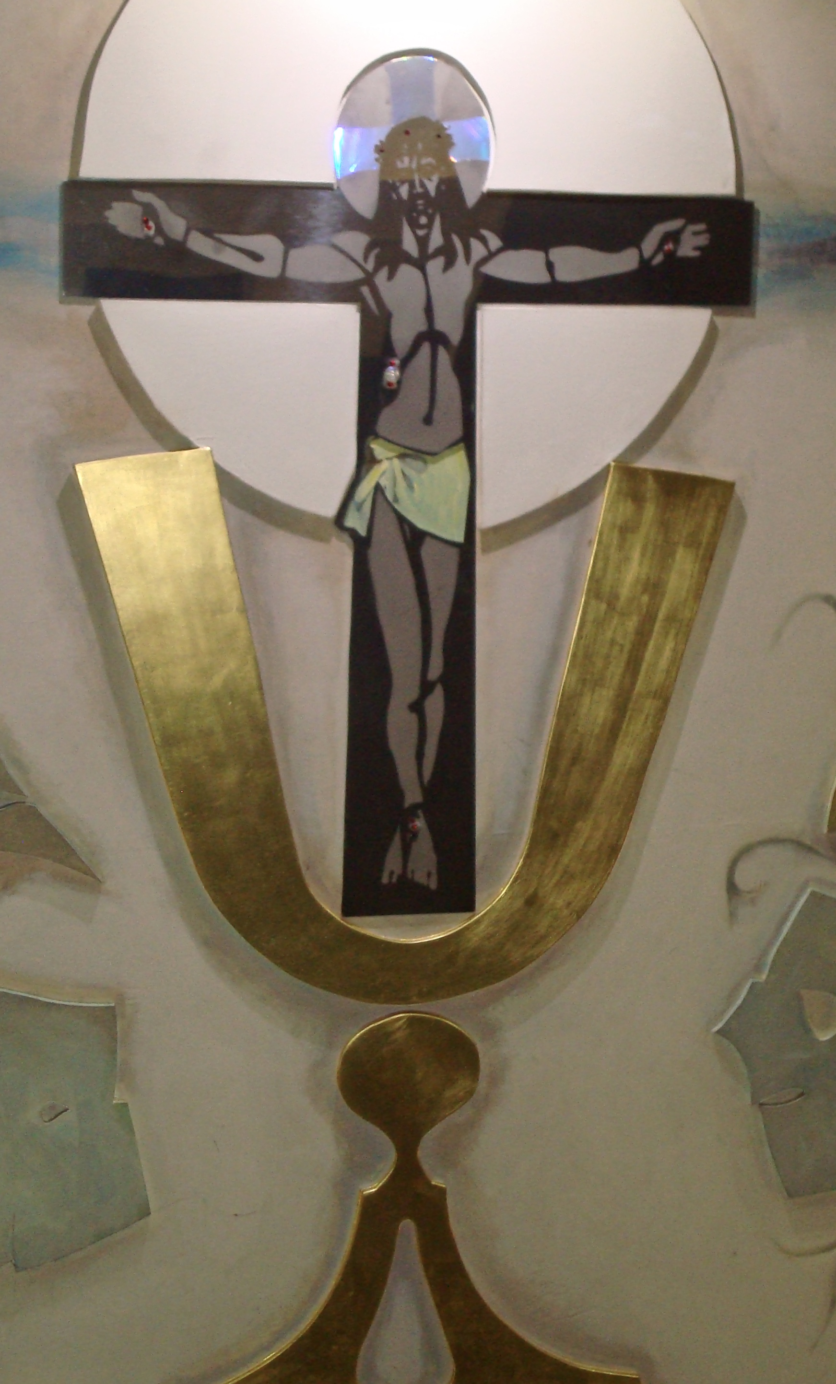  What we believe  God’s plan for humanity is that we would always be in relationship with him. In fact, we are made to be with God forever, because he made us in his “image and likeness”. But, humans have sinned and this sin has caused a break in our relationship with God. Still, God had a plan to save us. He sent his Son, Jesus, to come and win us back to God. He lived, died, and rose from the dead in order to gain power over our sin and death. He laid down his own life, so that we can have eternal life. Now that we have this opportunity, it is up to us to respond to his gift of grace and mercy. Jesus waits for each of us to say “yes” to repenting of our sins, believing in him, being baptized, and living a life that glorifies God, so we can live forever in Heaven with him and as many others as possible. The choice is your own. Would you like to choose this grace today? |  |  | What you can expect from our Parish  - A warm welcome, a smile and a helping hand  - Holy Mass, morning prayer, weekly eucharistic adoration, rosary, Lectio Divina and prayer groups  - Opportunities for prayer for specific intentions (intercessory prayer)  - Invitations to explore and deepen your faith, no matter the starting point, through regular prayer, study groups and pilgrimages  - Preparation and guidance in order to receive the Sacraments: Baptism, Reconciliation, Holy Communion, Confirmation, Marriage, Anointing of the Sick and even possible Ordination.  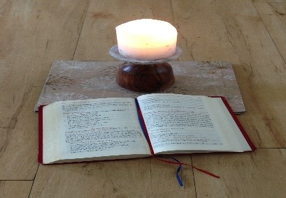  - Opportunities for social impact, through support of local initiatives such as the Soup Run, Colchester Food Bank, as well as international initiatives such as CaFOD etc. See our website for details  - A wide variety of Parish activities and social events: after mass coffee & biscuits, the Art Group, Befriending & Support Group, Ladies Coffee Morning, Wednesday Friendship Group, Climate Change talks & many Parish celebrations through the year  - Encouragement to contribute your skills and talents to the life of the Parish.

